24.75: a) We are to show the transformation from one circuit to the other:

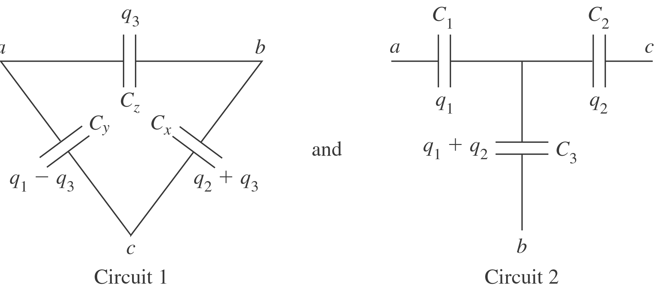

From Circuit 1: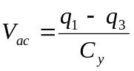and 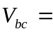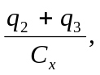 where 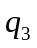is derived from 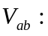
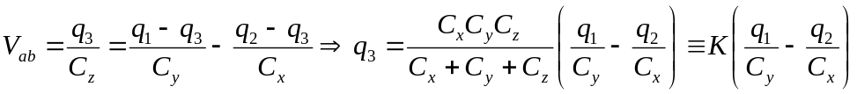
From Circuit 2: 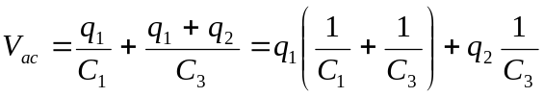and
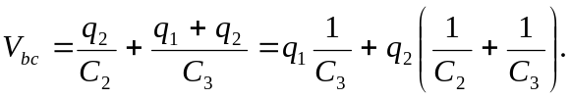
Setting the coefficients of the charges equal to each other in matching potential equations from the two circuits results in three independent equations relating the two sets of capacitances. The set of equations are:
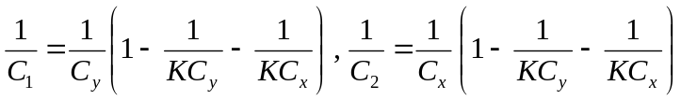and 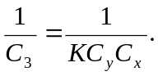
From these, subbing in the expression for 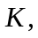 we get:
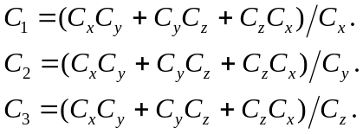

b) Using the transformation of part (a) we have:
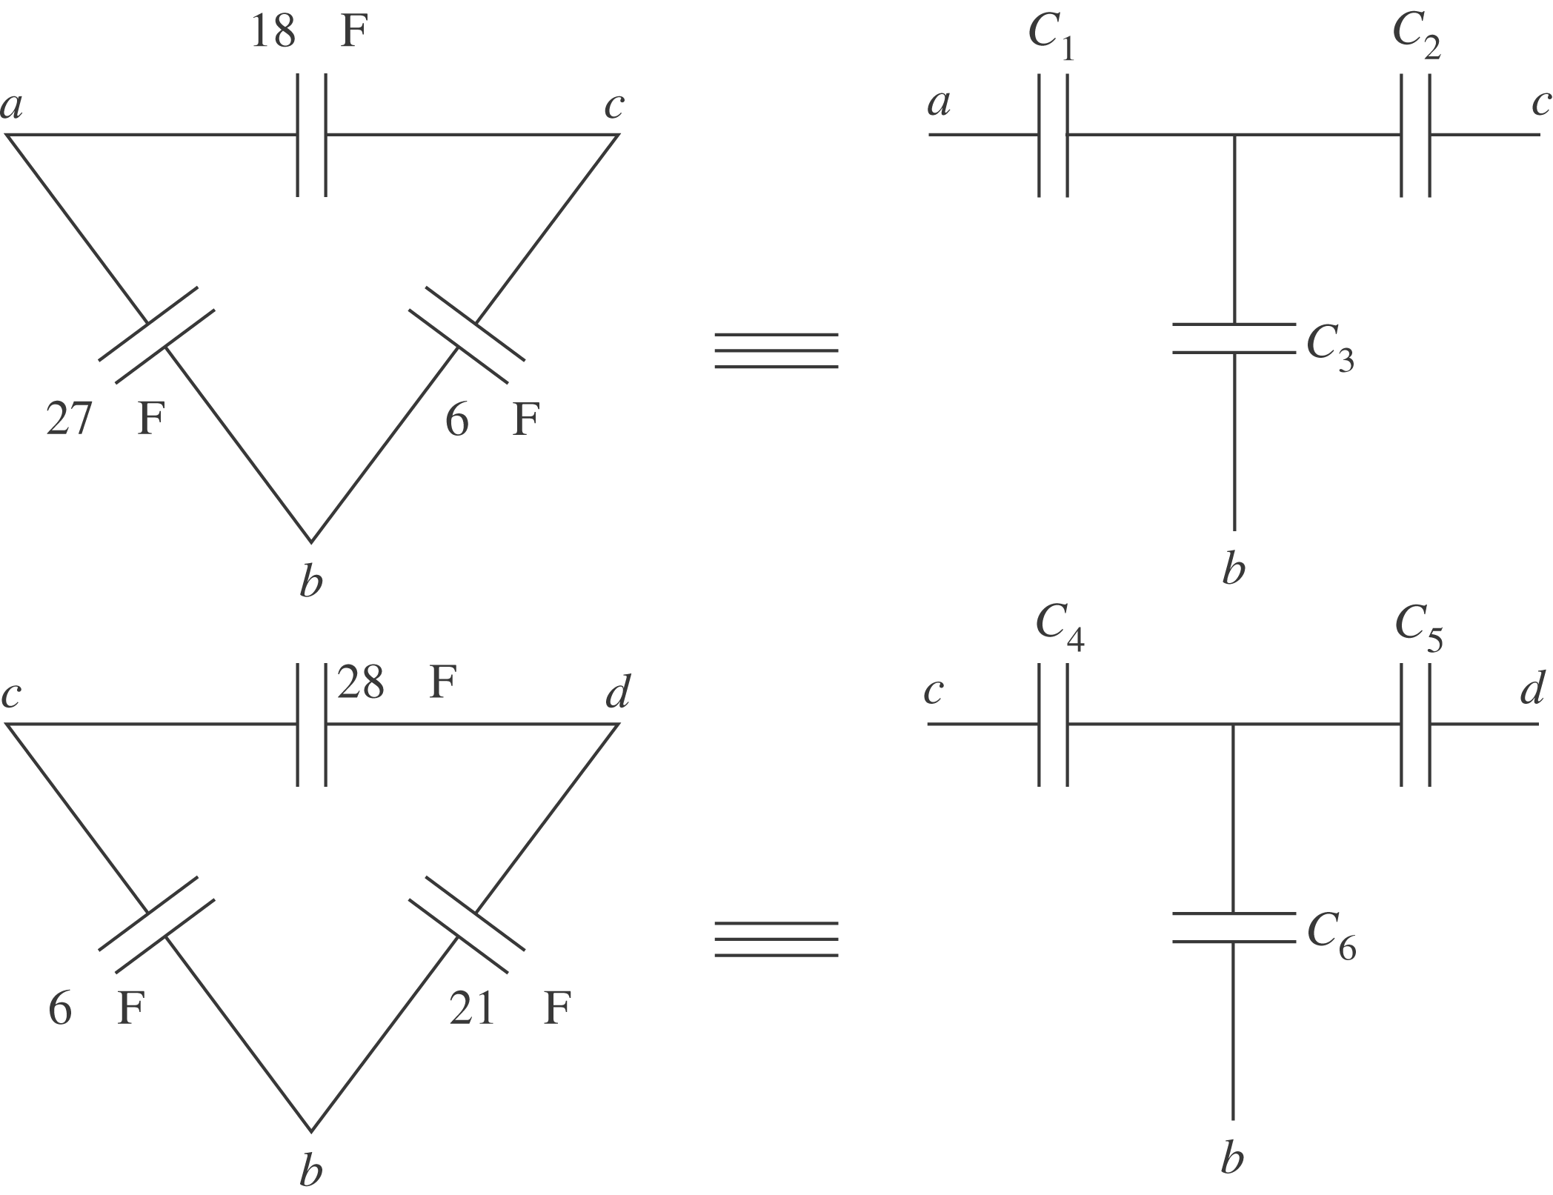
Where and 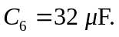 Now the total equivalent capacitance is:
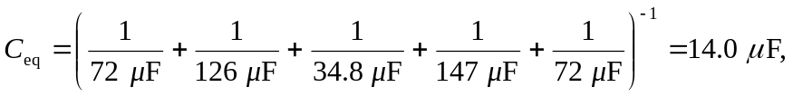
where the 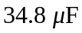comes from:
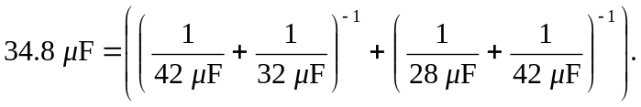
c) The circuit diagram can be re-drawn as shown on the next page. The overall charge is given by:
And this is also the charge over the 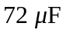 capacitors.
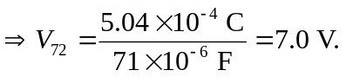
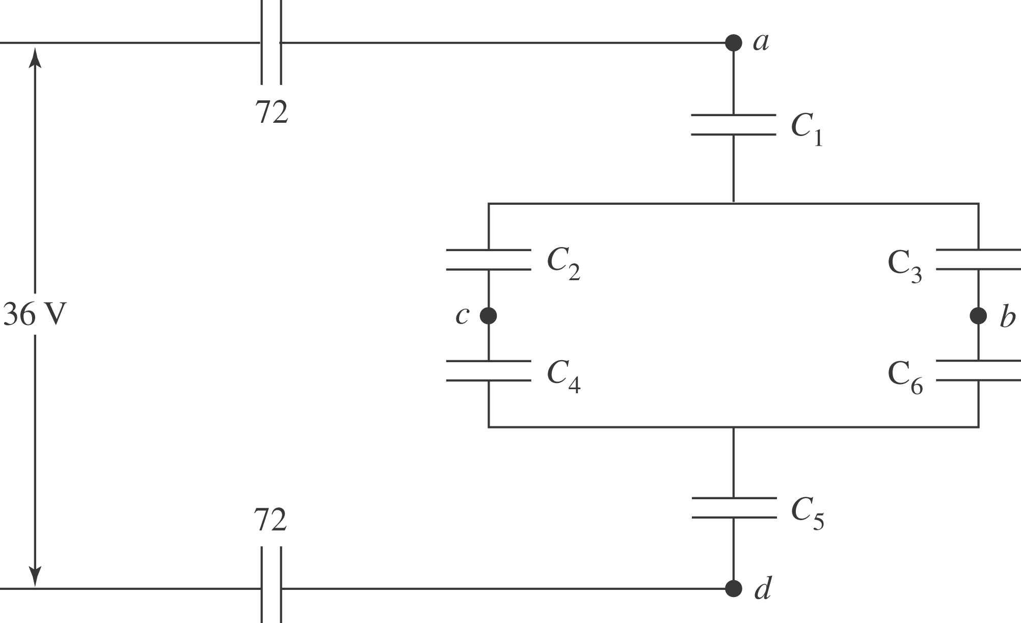
Next we will find the voltage over the numbered capacitors, and their associated voltages. Then those voltages will be changed back into voltage of the original capacitors, and then their charges.
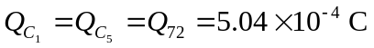
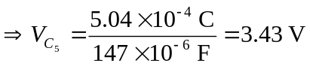 and 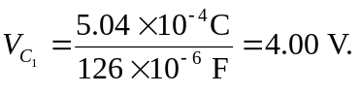
But 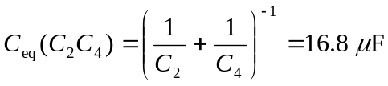 and 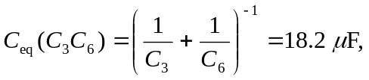 so:
